CSA4723 – DEEP LEARNING FOR DISASTER MANAGEMENT
B. Rishitha
192324130
1. Construct and verify the performance of bi-level and multi-level confusion
matrix using Python.
AIM:
To construct and verify the performance of bi-level (binary) and multi-level (multi-class) confusion matrices using Python, and to analyse the accuracy and classification performance of machine learning models.
ALGORITHM:
For Bi-level (Binary) Confusion Matrix
- Import required libraries — sklearn.metrics, matplotlib, and seaborn.
- Define true labels (y_true) and predicted labels (y_pred) for binary classification (0 or 1).
- Use confusion_matrix() to compute the confusion matrix.
- Display it using seaborn.heatmap() for visualization.
- Compute performance metrics using:
  - accuracy_score()
  - classification_report()
- Display the results.
CODE:
import matplotlib.pyplot as plt
import seaborn as sns
from sklearn.metrics import confusion_matrix, classification_report, accuracy_score
y_true_binary = [0, 1, 0, 1, 1, 0, 1, 0]
y_pred_binary = [0, 1, 0, 0, 1, 0, 1, 1]
cm_binary = confusion_matrix(y_true_binary, y_pred_binary)
plt.figure(figsize=(5, 4))
sns.heatmap(cm_binary, annot=True, fmt='d', cmap='Blues', cbar=False)
plt.title("Bi-level (Binary) Confusion Matrix")
plt.xlabel("Predicted Labels")
plt.ylabel("True Labels")
plt.show()
print("Binary Classification Report:")
print(classification_report(y_true_binary, y_pred_binary))
print("Accuracy:", accuracy_score(y_true_binary, y_pred_binary))

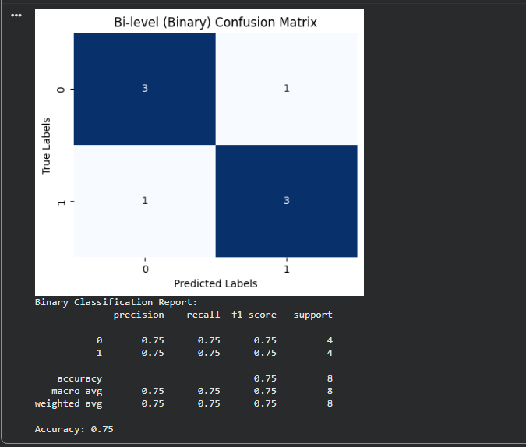

2. Verification of the overfitting issue by using a chosen numerical database using Python.
Aim: To demonstrate and verify the issue of overfitting in machine learning by training a model on a numerical dataset and analyzing its performance on both training and test data.
Algorithm:
Step 1: Import required libraries
Import libraries such as pandas, numpy, matplotlib, and sklearn for data handling, model training, and visualization.
Step 2: Load the dataset
Choose a suitable numerical dataset (e.g., sklearn.datasets.load_diabetes() or load_boston()).
Step 3: Split the dataset
Divide the dataset into training and testing sets using train_test_split().
Step 4: Train a simple model
Train a model (e.g., Linear Regression) on the training data and measure its performance.
Step 5: Train a complex/overfitted model
Use a more complex model (e.g., Decision Tree Regressor with no pruning or high depth) on the same training data.
Step 6: Evaluate both models
Compare the training accuracy and testing accuracy (or errors) of both models.
Overfitting occurs when the model performs very well on training data but poorly on testing data.
Step 7: Visualize the results
Plot model performance (e.g., training vs testing error) to clearly show the overfitting behavior.
Code:
from sklearn.datasets import load_wine
from sklearn.model_selection import train_test_split
from sklearn.tree import DecisionTreeClassifier
from sklearn.metrics import accuracy_score
import matplotlib.pyplot as plt

# Load numerical dataset (Wine dataset)
data = load_wine()
X = data.data
y = data.target
# Split data: 70% training, 30% testing
X_train, X_test, y_train, y_test = train_test_split(X, y, test_size=0.3, random_state=42)
# Model 1: Overfitted Decision Tree (no depth limit)
overfit_model = DecisionTreeClassifier(random_state=42)
overfit_model.fit(X_train, y_train)
train_acc_over = accuracy_score(y_train, overfit_model.predict(X_train))
test_acc_over = accuracy_score(y_test, overfit_model.predict(X_test))
print("🔹 Overfitted Model (No Depth Limit)")
print(f"Training Accuracy: {train_acc_over:.3f}")
print(f"Testing Accuracy: {test_acc_over:.3f}")
# Model 2: Regularized Decision Tree (with max_depth)
regularized_model = DecisionTreeClassifier(max_depth=3, random_state=42)
regularized_model.fit(X_train, y_train)
train_acc_reg = accuracy_score(y_train, regularized_model.predict(X_train))
test_acc_reg = accuracy_score(y_test, regularized_model.predict(X_test))
print("\n🔹 Regularized Model (max_depth=3)")
print(f"Training Accuracy: {train_acc_reg:.3f}")
print(f"Testing Accuracy: {test_acc_reg:.3f}")
# Visualization of Overfitting
plt.figure(figsize=(7, 5))
bars = plt.bar(["Overfit Train", "Overfit Test", "Reg Train", "Reg Test"],
[train_acc_over, test_acc_over, train_acc_reg, test_acc_reg],
color=["skyblue", "lightcoral", "limegreen", "orange"])
plt.title("Verification of Overfitting (Wine Dataset)")
plt.ylabel("Accuracy")
plt.ylim(0, 1.05)
# Annotate accuracy values on the bars
for bar in bars:
height = bar.get_height()
plt.text(bar.get_x() + bar.get_width()/2, height - 0.05,
f"{height:.2f}", ha='center', color='black', fontsize=10)
plt.show()
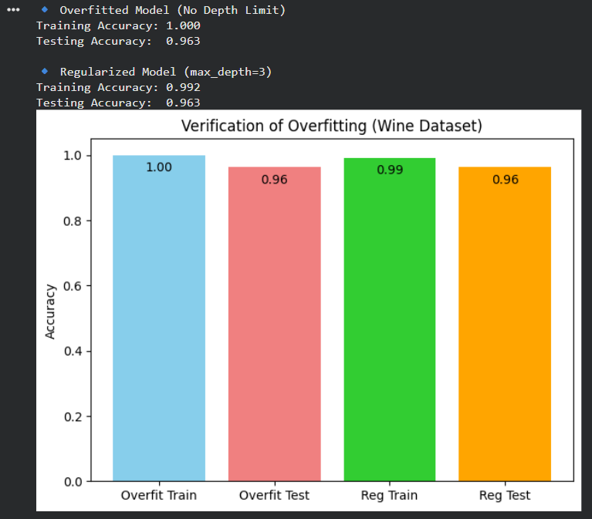
3. Analysing the performance of linear regression process using a chosen
numerical database using Python.
Aim: To analyze the performance of the Linear Regression algorithm on a chosen numerical dataset by training the model, making predictions, and evaluating its performance using suitable metrics.
Algorithm:
Step 1: Import libraries
Import necessary libraries such as pandas, numpy, matplotlib, and sklearn for data loading, model building, and evaluation.
Step 2: Load the dataset
Select and load a numerical dataset (e.g., sklearn.datasets.load_diabetes() or load_boston()).
Step 3: Split the dataset
Divide the dataset into training and testing sets using train_test_split() from sklearn.model_selection.
Step 4: Train the Linear Regression model
Use LinearRegression() from sklearn.linear_model to train the model on the training data.
Step 5: Make predictions
Use the trained model to predict target values for the test data.
Step 6: Evaluate model performance
Evaluate the model using metrics such as:
- Mean Squared Error (MSE)
- Root Mean Squared Error (RMSE)
- R² Score (Coefficient of Determination)
Step 7: Visualize results
Plot actual vs predicted values to visualize how well the model fits the data.
Code:
from sklearn.datasets import fetch_california_housing
from sklearn.model_selection import train_test_split
from sklearn.linear_model import LinearRegression
from sklearn.metrics import mean_absolute_error, mean_squared_error, r2_score
import matplotlib.pyplot as plt
import numpy as np
# Step 1: Load dataset
data = fetch_california_housing()
X = data.data
y = data.target
# Step 2: Split dataset (70% train, 30% test)
X_train, X_test, y_train, y_test = train_test_split(X, y, test_size=0.3, random_state=42)
# Step 3: Train Linear Regression Model
model = LinearRegression()
model.fit(X_train, y_train)
# Step 4: Predict on Test Data
y_pred = model.predict(X_test)
# Step 5: Evaluate Performance
mae = mean_absolute_error(y_test, y_pred)
mse = mean_squared_error(y_test, y_pred)
rmse = np.sqrt(mse)
r2 = r2_score(y_test, y_pred)
print("🔹 Linear Regression Performance Analysis 🔹")
print(f"Mean Absolute Error (MAE): {mae:.3f}")
print(f"Mean Squared Error (MSE): {mse:.3f}")
print(f"Root Mean Squared Error (RMSE): {rmse:.3f}")
print(f"R² Score: {r2:.3f}")
# Step 6: Visualization
plt.figure(figsize=(6,6))
plt.scatter(y_test, y_pred, color='blue', edgecolor='k', alpha=0.6)
plt.plot([y_test.min(), y_test.max()], [y_test.min(), y_test.max()], 'r--', lw=2)
plt.title("Actual vs Predicted Values (Linear Regression)")
plt.xlabel("Actual Prices")
plt.ylabel("Predicted Prices")
plt.show()
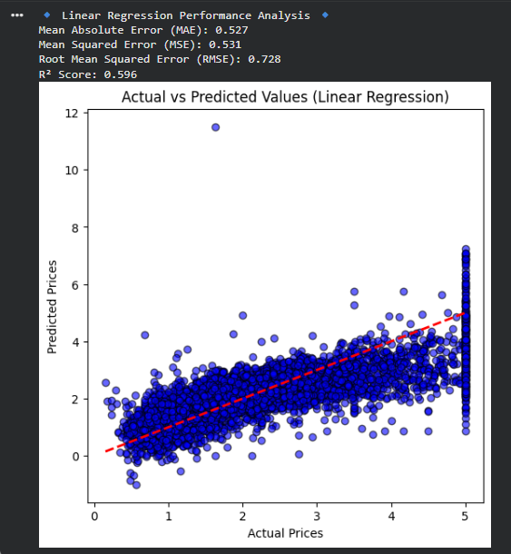
4. Analysing the performance of logistic regression process using a chosen
numerical database using Python
Aim: To analyze the performance of the Logistic Regression algorithm on a chosen numerical dataset by training the model, making predictions, and evaluating its classification performance using standard evaluation metrics.
Algorithm:
Step 1: Import required libraries
Import essential Python libraries such as pandas, numpy, matplotlib, and sklearn for data handling, model creation, and evaluation.
Step 2: Load the dataset
Select and load a suitable numerical classification dataset (e.g., sklearn.datasets.load_breast_cancer() or load_iris()).
Step 3: Split the dataset
Divide the data into training and testing sets using train_test_split() from sklearn.model_selection.
Step 4: Data preprocessing (if required)
Normalize or scale the data using StandardScaler() to improve model performance.
Step 5: Train the Logistic Regression model
Use LogisticRegression() from sklearn.linear_model to train the model on the training data.
Step 6: Make predictions
Use the trained model to predict the target values for the test data.
Step 7: Evaluate model performance
Evaluate the model using classification metrics such as:
- Accuracy Score
- Confusion Matrix
- Precision, Recall, and F1-score
Step 8: Visualize results
Plot the confusion matrix or decision boundary to visualize the model’s performance.
Code:
from sklearn.datasets import load_iris
from sklearn.model_selection import train_test_split
from sklearn.linear_model import LogisticRegression
from sklearn.metrics import confusion_matrix, classification_report, accuracy_score
import seaborn as sns
import matplotlib.pyplot as plt
data = load_iris()
X = data.data
y = data.target
X_train, X_test, y_train, y_test = train_test_split(X, y, test_size=0.3, random_state=42)
model = LogisticRegression(max_iter=200)
model.fit(X_train, y_train)
y_pred = model.predict(X_test)
acc = accuracy_score(y_test, y_pred)
cm = confusion_matrix(y_test, y_pred)
report = classification_report(y_test, y_pred)
print("🔹 Logistic Regression Performance Analysis 🔹")
print(f"Accuracy: {acc:.3f}\n")
print("Classification Report:\n", report)
plt.figure(figsize=(6,5))
sns.heatmap(cm, annot=True, fmt='d', cmap='Blues', cbar=False,
xticklabels=data.target_names, yticklabels=data.target_names)
plt.title("Confusion Matrix - Logistic Regression")
plt.xlabel("Predicted Labels")
plt.ylabel("True Labels")
plt.show()
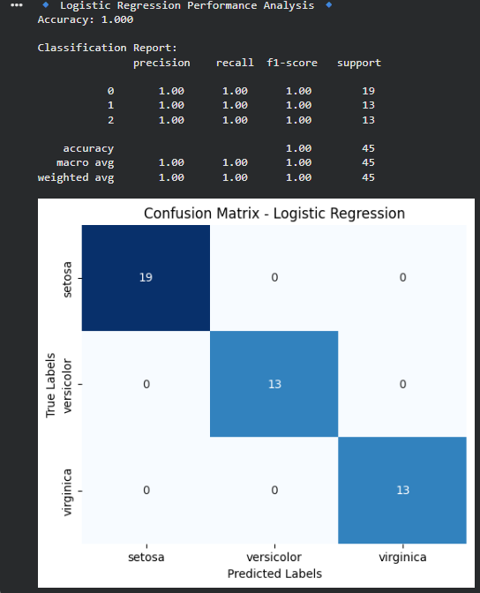

5. Demonstrating the performance of gradient descent algorithm using Python
Aim: To implement and demonstrate the Gradient Descent algorithm in Python and analyze how it minimizes a cost function iteratively to reach the optimal solution.
Algorithm:
Step 1: Import required libraries
Import necessary libraries such as numpy and matplotlib for numerical computation and visualization.
Step 2: Define the cost function
Choose a simple mathematical function (e.g., $f(x)=x^{2}$) to minimize.
Step 3: Compute the derivative of the function
Define the gradient (derivative) of the function, e.g., $f^{'}(x)=2x$.
Step 4: Initialize parameters
Set an initial value for the variable $x$, a learning rate (η), and the number of iterations.
Step 5: Apply the gradient descent update rule
For each iteration:
$$x_{\text{new}}=x_{\text{old}}-η×f^{'}(x_{\text{old}})$$
Store the updated values for visualization.
Step 6: Stop when convergence is reached
Repeat the updates until the gradient becomes very small or the number of iterations is completed.
Step 7: Visualize the results
Plot the cost function and show the path of descent to illustrate how the algorithm converges to the minimum.
Code:
# ✅ Demonstrating the Performance of Gradient Descent Algorithm

import numpy as np
import matplotlib.pyplot as plt

# -----------------------------
# Step 1: Create a simple linear dataset
# -----------------------------
np.random.seed(42)
X = 2 * np.random.rand(100, 1)
…plt.legend()
plt.show()
